A Novel Method for Handwritten Digit Recognition System

**Submitted by**

|  |  |
| --- | --- |
| **VIGNESHKUMAR P** | **921019104056** |
| **PENNYCUICK S** | **921019104036** |
| **SANJAYKUMAR R** | **921019104043** |
| **UMAMAHESWARAN G** | **921019104053** |

**BACHELOR OF ENGINEERING**

**In**

**COMPUTER SCIENCE AND ENGINEERING**



**NADAR SARASWATHI COLLEGE OF ENGINEERING AND**

**TECHNOLOGY, THENI-625531**

**ANNA UNIVERSITY:**

**CHENNAI**

**ARTFICIAL INTELLIGENCE DOMAIN**

**TEAM ID - PNT2022TMID48836**

**Project Report Format**

**1. INTRODUCTION**

1.1 Project Overview

1.2 Purpose

**2. LITERATURE SURVEY**

2.1 Existing problem

2.2 References

2.3 Problem Statement Definition

**3. IDEATION &amp; PROPOSED SOLUTION**

3.1 Empathy Map Canvas

3.2 Ideation &amp; Brainstorming

3.3 Proposed Solution

3.4 Problem Solution fit

**4. REQUIREMENT ANALYSIS**

4.1 Functional requirement

4.2 Non-Functional requirements

**5. PROJECT DESIGN**

5.1 Data Flow Diagrams

5.2 Solution &amp; Technical Architecture

5.3 User Stories

**6. PROJECT PLANNING &amp; SCHEDULING**

6.1 Sprint Planning &amp; Estimation

6.2 Sprint Delivery Schedule

6.3 Reports from JIRA

**7. CODING &amp; SOLUTIONING (Explain the features added in the project along with code)**

7.1 Feature 1

7.2 Feature 2

7.3 Database Schema (if Applicable)

**8. TESTING**

8.1 Test Cases

8.2 User Acceptance Testing

**9. RESULTS**

9.1 Performance Metrics

**10. ADVANTAGES & DISADVANTAGES**

**11. CONCLUSION**

**12. FUTURE SCOPE**

**13. APPENDIX**

Source Code

GitHub &amp; Project Demo Link

## INTRODUCTION

### PROJECT OVERVIEW

In computer technology and artificial intelligence, machine learning and deep learning are crucial. Human effort can be decreased in many different areas with the help of deep learning and machine learning, including recognition, learning, predictions, and many more.

Handwritten Digit Recognition is the ability of computer systems to recognise handwritten digits from various sources, such as images, documents, and so on. This project aims to let users take advantage of machine learning to reduce manual tasks in recognizing digits.

### PURPOSE

Digit recognition systems are able to identify numbers from a variety of sources, including emails, bank checks, papers, images, etc. They can also be used in a variety of real- world situations, such as online handwriting recognition on computer tablets or systems, identifying vehicle licence plates, processing bank cheque amounts, and reading numbers from forms that have been filled out by hand (such as tax forms).

# CHAPTER 2

## LITERATURE SURVEY

### EXISTING PROBLEM

The fundamental problem with handwritten digit recognition is that handwritten digits do not always have the same size, width, orientation, and margins since they vary from person to person. Additionally, there would be issues with identifying the numbers because of similarities between numerals like 1 and 7, 5 and 6, 3 and 8, 2 and 5, 2 and 7, etc. Finally, the individuality and variation of each individual's handwriting influence the structure and appearance of the digits.

### REFERENCES

#### Hao Y., Shi Y., Zhang D., Zhu X. 2001, ”An effective result-feedback neural algorithm for handwritten character recognition‘ International Journal of Neural Parallel & Science Computations, Vol. 9z No. 2, Pp.139~150

In this paper, a new algorithm of handwritten character recognition based on result-feedback is proposed. It is designed as an effective neural network by adding confidence back-propagation and input modification, thus both pre-processing and recognition operations are closely integrated together. The convergence of the algorithm is proved and many experiments show that the error rate in such a result-feedback neural network (RFNN) can be greatly reduced as well as the robust to environmental noise

#### Kimura, F. and Shiridhar, M. (1991). Handwritten numerical recognition based on multiple algorithms. Pattern Recognition, no. 10, vol. 24, pp. 969-983

In this paper, the authors developed two algorithms for application to recognition of unconstrained isolated handwritten numerals. While both algorithms yielded very low error rates, the authors combined the two algorithms in different ways to study the best polling strategy and realized significant improvement in performance.

#### M. Shridhar and A. Badreldin, Recognition of isolated and simply connected handwritten numerals, Pattern Recognition 19, 1-12 (1986).

In this paper the authors describe the results of their investigation into the development of a recognition algorithm for identifying numerals that may be isolated or connected, broken or continuous. Using a structural classification scheme, the recognition algorithm is derived as a tree classifier. In an extensive test experiment, an accuracy of 99% was realized with isolated numerals. When connected numerals were also included a recognition accuracy of 93% was obtained.

#### Bora, Mayur Bhargab, Dinthisrang Daimary, Khwairakpam Amitab, and Debdatta Kandar. "Handwritten character recognition from images using CNN-ECOC." Procedia Computer Science 167 (2020): 2403-2409.

In this paper Mayur Bhargab Bora, Dinthisrang Daimary, Khwairakpam Amitab, Debdatta Kandar et. mentioned that The OCR is a process of classifying the optical patterns present in a digital image to the corresponding characters.he OCR is a process of classifying the optical patterns present in a digital image to the corresponding characters.The character recognition is achieved through important steps of feature extraction and classification. The OCR system simulates the human capability to recognize. And the advantages are he CNN is used for feature extraction and ECOC for recognition of characters. In order to find a suitable feature extractor, three popular CNN architectures have been explored, namely LeNet, AlexNet and ZfNet.

AlexNet is the most suitable CNN for combining with ECOC, in order to recognize handwritten characters.

### PROBLEM STATEMENT DEFINITION

For years, the traffic department has been combating traffic law violators. These offenders endanger not only their own lives, but also the lives of other individuals. Punishing these offenders is critical to ensuring that others do not become like them. Identification of these offenders is next to impossible because it is impossible for the average individual to write down the license plate of a reckless driver. Therefore, the goal of this project is to help the traffic department identify these offenders and reduce traffic violations as a result.

# CHAPTER 3

## IDEATION AND PROPOSED SOLUTION

### EMPATHY MAP CANVAS

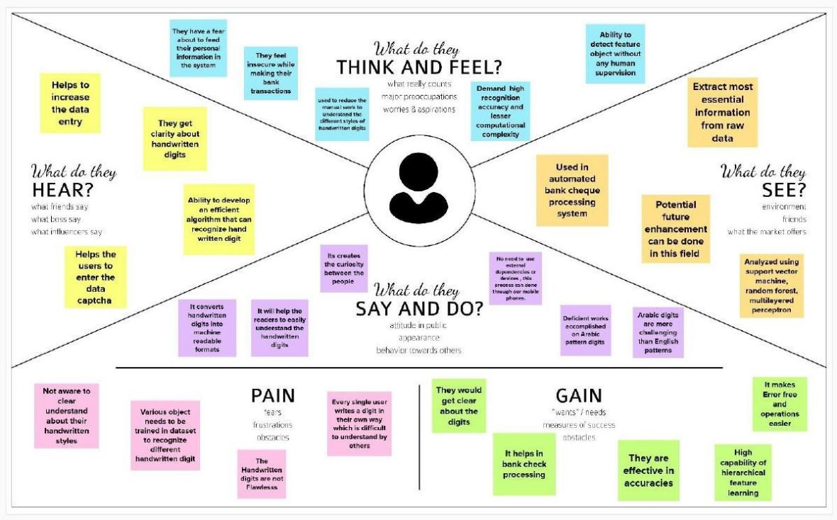

* 1. **IDEATION & BRAINSTORMING**

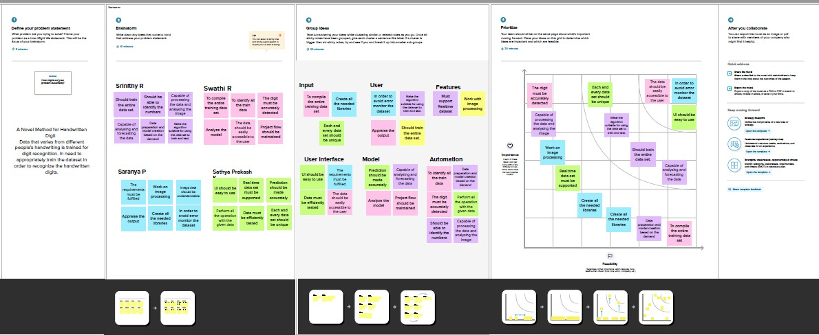

### PROPOSED SOLUTION

|  |  |  |
| --- | --- | --- |
| **S.NO** | **PARAMETER** | **DESCRIPTION** |
| 1 | Problem Statement | To create an application that recognizes handwritten digits |
| 2 | Idea / Solution Description | The application takes an image as the input and accurately detects the digits in it. |
| 3 | Novelty / Uniqueness | Instead of recognizing every text, the application accurately recognizes only the digits |
| 4 | Social Impact / Customer Satisfaction | This application reduces the manual tasks that need to be performed. This improves productivity in the workplace. |
| 5 | Business Model | The application can be integrated with tra c  surveillance cameras to recognize vehicle number plates  The application can be integrated with Postal systems to recognize the pin codes  e ectively |
| 6 | Scalability of the Solution | The application can easily be scaled to accept multiple inputs  and process them parallelly to further increase e ciency |

* 1. **PROBLEM SOLUTION FIT**

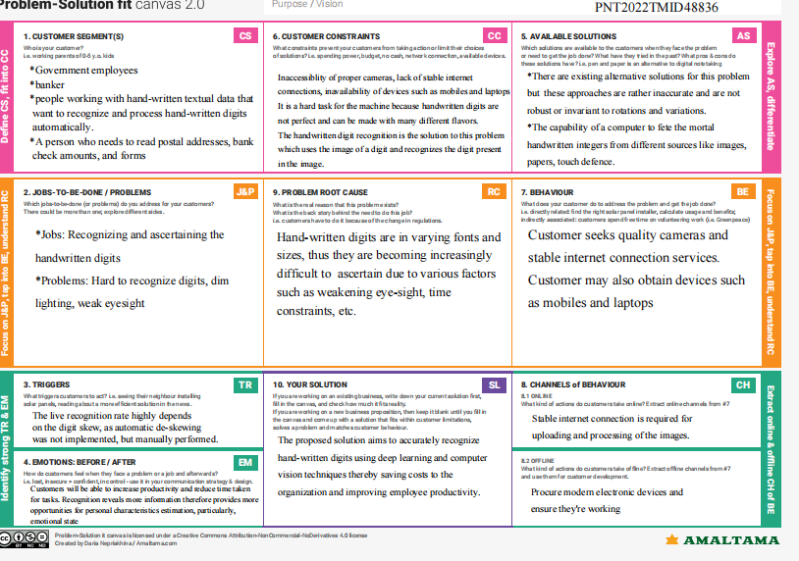

# CHAPTER 4

## REQUIREMENT ANALYSIS

### FUNCTIONAL REQUIREMENTS

|  |  |  |
| --- | --- | --- |
| **FR.NO** | **FUNCTIONAL REQUIREMENTS** | **SUB REQUIREMENTS** |
| FR-1 | Model Creation | Get access the MNIST dataset |
| Analyze the dataset |
| Define a CNN model |
| Train and Test the Model |
| FR-2 | Application Development | Create a website to let the user recognize handwritten digits. |
| Create a home page to upload images |
| Create a result page to display the results |
| Host the website to let the users use it from anywhere |
| FR-3 | Input Image Upload | Let users upload images of various formats. |
| Let users upload images of various size |
| Prevent users from uploading unsupported image formats |

|  |  |  |
| --- | --- | --- |
|  |  | Pre-Process the image to use it on the model |
|  |  | Create a database to store all the input images |
| FR-4 | Display Results | Display the result from the model |
| Display input image |
| Display accuracy the result |
| Display other possible predictions with their respective  accuracy |

* 1. **NON FUNCTIONAL REQUIREMENTS**

|  |  |  |
| --- | --- | --- |
| **NFR** | **NON-FUNCTIONAL REQUIREMENTS** | **DESCRIPTION** |
| NFR-1 | Usability | The application must be usable in all devices |
| NFR-2 | Security | The application must protect user uploaded image |
| NFR-3 | Reliability | The application must give an accurate result as much as possible |
| NFR-4 | Performance | The application must be fast and quick to load up |
| NFR-5 | Availability | The application must be available to use all the time |
| NFR-6 | Scalability | The application must scale along with the user base |

# CHAPTER 5

## PROJECT DESIGN

### DATA FLOW DIAGRAM

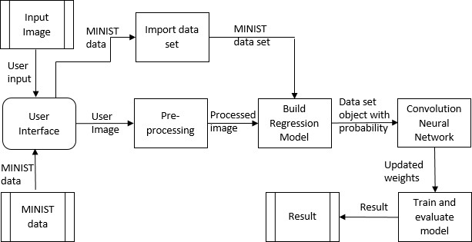

* 1. **SOLUTION & TECHNICAL ARCHITECTURE**

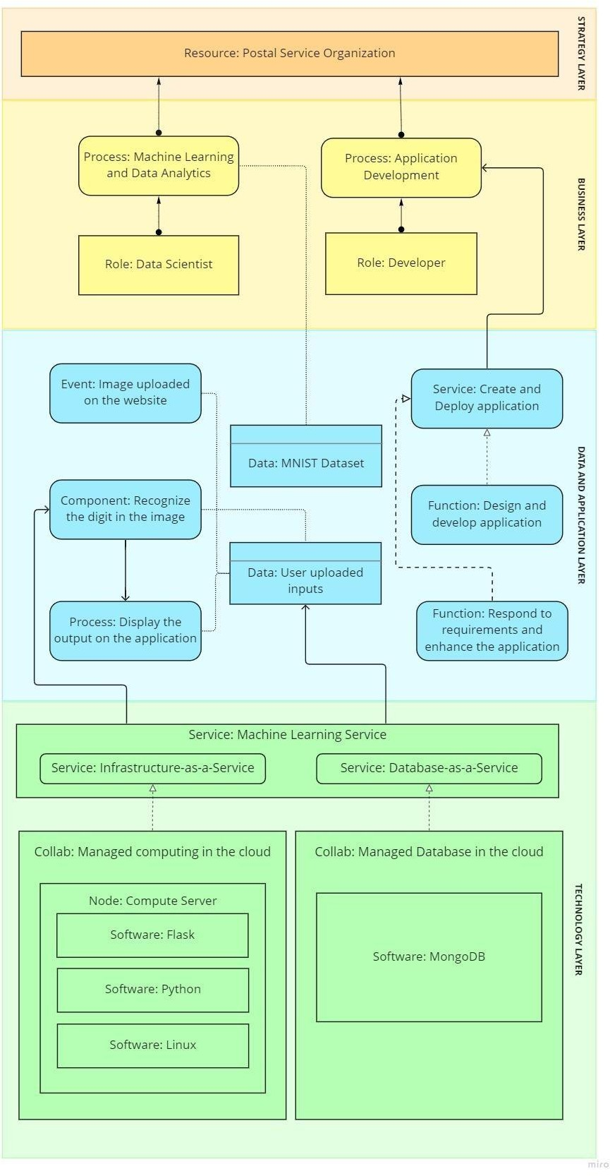

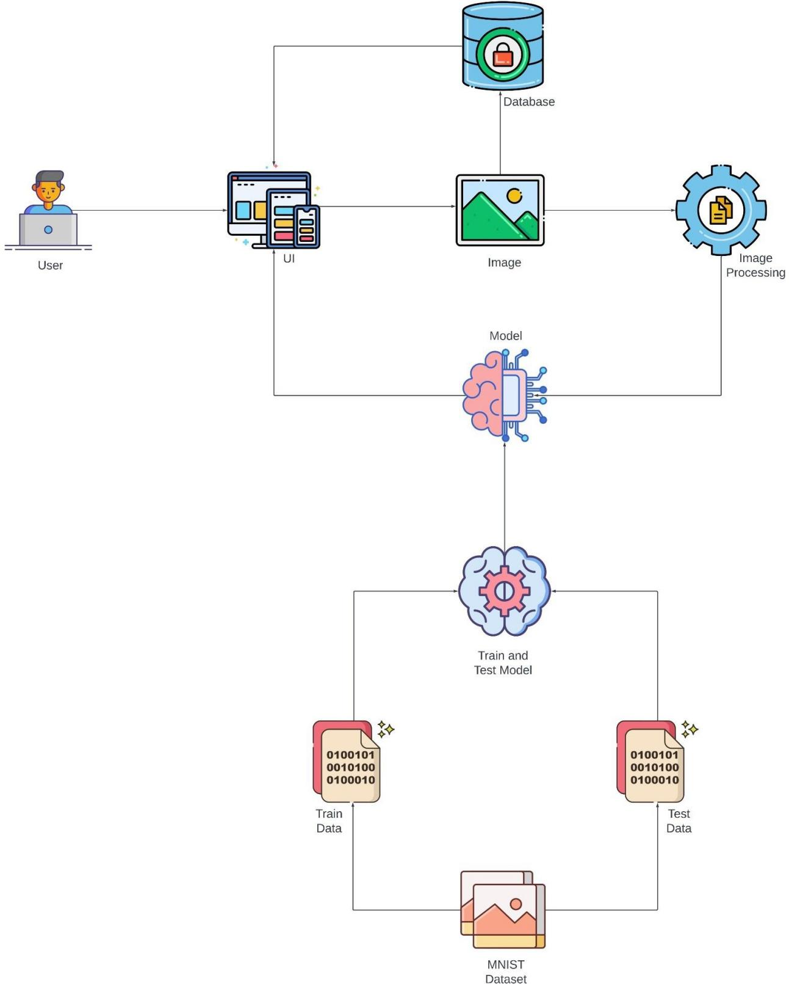

* 1. **USER STORIES**

|  |  |  |  |  |  |  |
| --- | --- | --- | --- | --- | --- | --- |
| **User Type** | **Functional Requirement**  **(Epic)** | **User Story**  **Number** | **User Story / Task** | **Acceptance criteria** | **Priority** | **Release** |
| Customer (Mobile user) | Registration | USN-1 | As a user, I can sign up for the application by providing my email address, password, and password  confirmation. | I can access my dashboard or account. | High | Sprint-1 |
|  |  | USN-2 | As a user, Once I've signed up for the application, I'll get a confirmation  email. | I can get a confirmation email and confirm it. | High | Sprint-2 |
|  |  | USN-3 | As a user, Through Gmail or Twitter, I may sign up for the application. | I may sign up and access the dashboard using my Gmail or Twitter  accounts. | Medium | Sprint-2 |
|  | Login | USN-4 | As a user, I can access the application by entering my password and  email. | I can login to the application | High | Sprint-1 |
|  | Dashboard | USN-5 | Visit the dashboard and look at the information  regarding our project. | The front page is user-  friendly, and  I can read instructions. | Low | Sprint-1 |
|  | Upload Image | USN-6 | As a user, I am able to upload digital document photos to the application. | As a user, I can enter digital document photos into the  application. | High | Sprint-3 |
|  | Predict | USN-7 | As a user, I can  able to get the recognised digit | From digital  documents or images, I | High | Sprint-3 |

|  |  |  |  |  |  |  |
| --- | --- | --- | --- | --- | --- | --- |
|  |  |  | as output from the images of digital  documents or images | may access the identified digits. |  |  |
|  |  | USN-8 | As a user, In order to obtain the output as accurate as possible, I will train and test the input. | I am able to test and train the application till the results are as accurate  as possible. | Medium | Sprint-4 |
| Customer (Web user) | Login | USN-9 | As a user, By entering my email and password, I can  use the application. | I can access my account | Medium | Sprint-4 |
| Customer Care Executive | Dashboard | USN-10 | Upload the image | Recognize and get the output | High | Sprint-1 |
| Administrat or | Security | USN-11 | Updated the features | Checking the security | Medium | Sprint-1 |

# CHAPTER

**6**

## PROJECT PLANNING AND SCHEDULING

* 1. **SPRINT PLANNING AND ESTIMATION**

|  |  |  |  |  |  |  |
| --- | --- | --- | --- | --- | --- | --- |
| **Sprint** | **Functional Requirement (Epic)** | **User Story Number** | **User Story / Task** | **Story Points** | **Priority** | **Team Members** |
| Sprint-1 | Data Collection | USN-1 | As a user, I can collect the dataset from various resources with different handwritings. | 10 | Low | Vigneshkumar,Sanjaykumar |
| Sprint-1 | Data Preprocessing | USN-2 | As a user, I can load the dataset, handling the missing data, scaling and split data into train and test. | 10 | Medium | pennycuick |
| Sprint-2 | Model Building | USN-3 | As a user, I will get an application with ML model which provides high accuracy of recognized handwritten digit. | 5 | High | sanjaykumar |
| Sprint-2 | Add CNN layers | USN-4 | Creating the model and  adding the | 5 | High | Vigneshkumar |

|  |  |  |  |  |  |  |
| --- | --- | --- | --- | --- | --- | --- |
|  |  |  | input, hidden, and output layers to it. |  |  |  |
| Sprint-2 | Compiling the model | USN-5 | With both the training data defined and model defined, it's time to configure the learning process. | 2 | Medium | Sanjaykumar |
| Sprint-2 | Train & test the model | USN-6 | As a user, let us train our model with our image dataset. | 6 | Medium | Umamaheswaran,Pennycuick |
| Sprint-2 | Save the model | USN-7 | As a user, the model is saved & integrated with an android application or web application in order to predict something. | 2 | Low | Sanjaykumar,Vigneshkumar |
| Sprint-3 | Building UI Application | USN-8 | As a user, I will upload the handwritten digit image to the application by clicking a upload button. | 5 | High | Vigneshkumar |

# CHAPTER

|  |  |  |  |  |  |  |
| --- | --- | --- | --- | --- | --- | --- |
| Sprint-3 |  | USN-9 | As a user, I can know the details of the fundamental usage of the application. | 5 | Low | Sanjaykumar |
| Sprint-3 |  | USN-10 | As a user, I can see the predicted / recognized digits in the application. | 5 | Medium | Umamaheswaran,Pennycuick |
| Sprint-4 | Train the model on IBM | USN-11 | As a user, I train the model on IBM and integrate flask/Django with scoring end point. | 10 | High | Sanjaykumar,Vigneshkumar |
| Sprint-4 | Cloud Deployment | USN-12 | As a user, I can access the web application and make the use of the product from anywhere. | 10 | High | Vigneshkumar |

* 1. **SPRINT DELIVERY SCHEDULE**

| **Sprint** | **Total Story Points** | **Duration** | **Sprint Start Date** | **Sprint End Date (Planned)** | **Story Points Completed (as on Planned End Date)** | **Sprint Release Date (Actual)** |
| --- | --- | --- | --- | --- | --- | --- |
| Sprint-1 | 20 | 6 Days | 24 Oct 2022 | 29 Oct 2022 | 20 | 31 Oct 2022 |
| Sprint-2 | 20 | 6 Days | 31 Oct 2022 | 05 Nov 2022 | 20 | 05 Nov 2022 |
| Sprint-3 | 20 | 6 Days | 07 Nov 2022 | 12 Nov 2022 | 20 | 12 Nov 2022 |
| Sprint-4 | 20 | 6 Days | 14 Nov 2022 | 19 Nov 2022 | 20 | 19 Nov 2022 |

# CHAPTER

**7**

**CODING & SOLUTIONING**

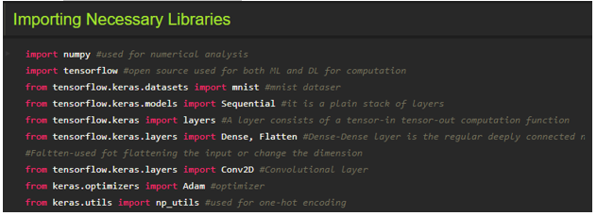

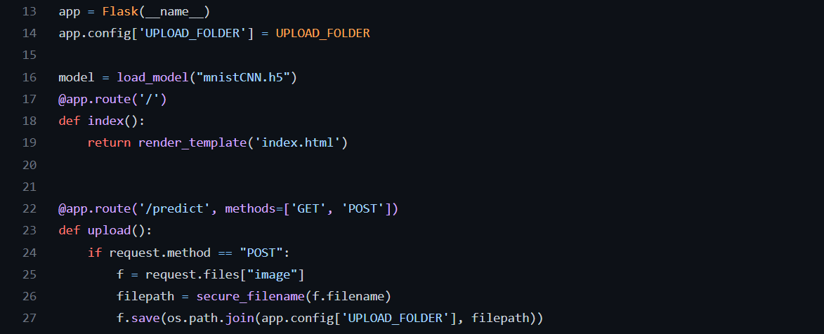

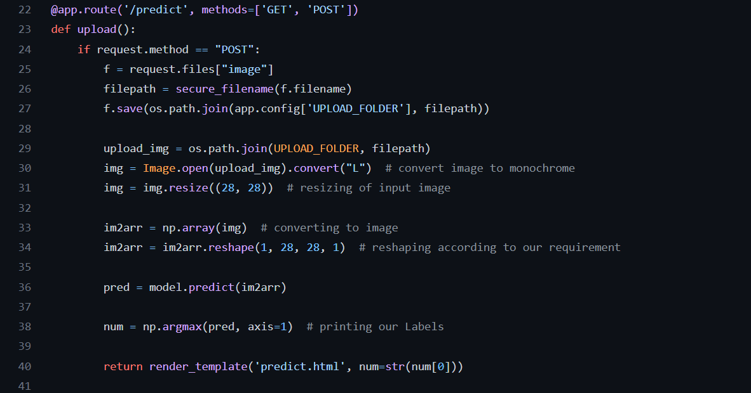

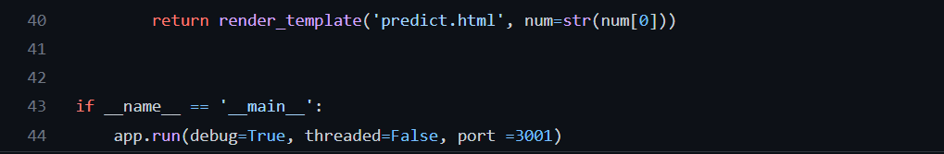

# CHAPTER 8

## TESTING

* 1. **TEST CASES**

|  |  |  |  |  |  |  |
| --- | --- | --- | --- | --- | --- | --- |
| **Test case ID** | **Feature Type** | **Component** | **Test Scenario** | **Expected Result** | **Actual Result** | **Status** |
| HP_TC_001 | UI | Home Page | Verify UI elements in the Home  Page | The Home page must be displayed properly | Working as expected | PASS |
| HP_TC_002 | UI | Home Page | Check if the UI elements are displayed  properly in different screen sizes | The Home page must be displayed properly in all sizes | The UI is not displayed  properly in screen size 2560 x 1801  and 768 x 630 | FAIL |
| HP_TC_003 | Functional | Home Page | Check if user can upload their file | The input image should be  uploaded to the application successfully | Working as expected | PASS |
| HP_TC_004 | Functional | Home Page | Check if user cannot upload unsupported  files | The application should not allow user to select a non image file | User is able to upload any file | FAIL |

|  |  |  |  |  |  |  |
| --- | --- | --- | --- | --- | --- | --- |
| HP_TC_005 | Functional | Home Page | Check if the page redirects to the result  page once the input is given | The page should redirect to the results page | Working as expected | PASS |
| BE_TC_001 | Functional | Backend | Check if all the routes are working properly | All the routes should properly work | Working as expected | PASS |
| M_TC_001 | Functional | Model | Check if the model can  handle various image sizes | The model should rescale the image  and predict the results | Working as expected | PASS |
| M_TC_002 | Functional | Model | Check if the model  predicts the digit | The model should predict the number | Working as expected | PASS |
| M_TC_003 | Functional | Model | Check if the model can  handle complex input  image | The model should predict the  number in the complex image | The model fails to identify the digit since the model is not built to handle  such data | FAIL |
| RP_TC_001 | UI | Result Page | Verify UI elements in  the Result Page | The Result page must be displayed properly | Working as expected | PASS |
| RP_TC_002 | UI | Result Page | Check if the input image is displayed properly | The input image should be displayed properly | The size of the input image exceeds the  display  container | FAIL |

|  |  |  |  |  |  |  |
| --- | --- | --- | --- | --- | --- | --- |
| RP_TC_003 | UI | Result Page | Check if the result is  displayed properly | The result should be displayed properly | Working as expected | PASS |
| RP_TC_004 | UI | Result Page | Check if the other  predictions are displayed  properly | The other predictions should be displayed properly | Working as expected | PASS |

### USER ACCEPTANCE TESTING 8.2.1 DEFECT ANALYSIS

|  |  |  |  |  |  |
| --- | --- | --- | --- | --- | --- |
| Resolution | Severity 1 | Severity 2 | Severity 3 | Severity 4 | Total |
| By Design | 1 | 0 | 1 | 0 | 2 |
| Duplicate | 0 | 0 | 0 | 0 | 0 |
| External | 0 | 0 | 2 | 0 | 2 |
| Fixed | 4 | 1 | 0 | 1 | 6 |
| Not Reproduced | 0 | 0 | 0 | 1 | 1 |
| Skipped | 0 | 0 | 0 | 1 | 1 |
| Won’t Fix | 1 | 0 | 1 | 0 | 2 |
| Total | 6 | 1 | 4 | 3 | 14 |

**8.2.2 TEST CASE ANALYSIS**

|  |  |  |  |  |
| --- | --- | --- | --- | --- |
| Section | Total Cases | Not Tested | Fail | Pass |
| Client Application | 10 | 0 | 3 | 7 |
| Security | 2 | 0 | 1 | 1 |
| Performance | 3 | 0 | 1 | 2 |
| Exception Reporting | 2 | 0 | 0 | 2 |

# CHAPTER 9

## RESULTS

### PERFORMANCE METRICS

* + 1. 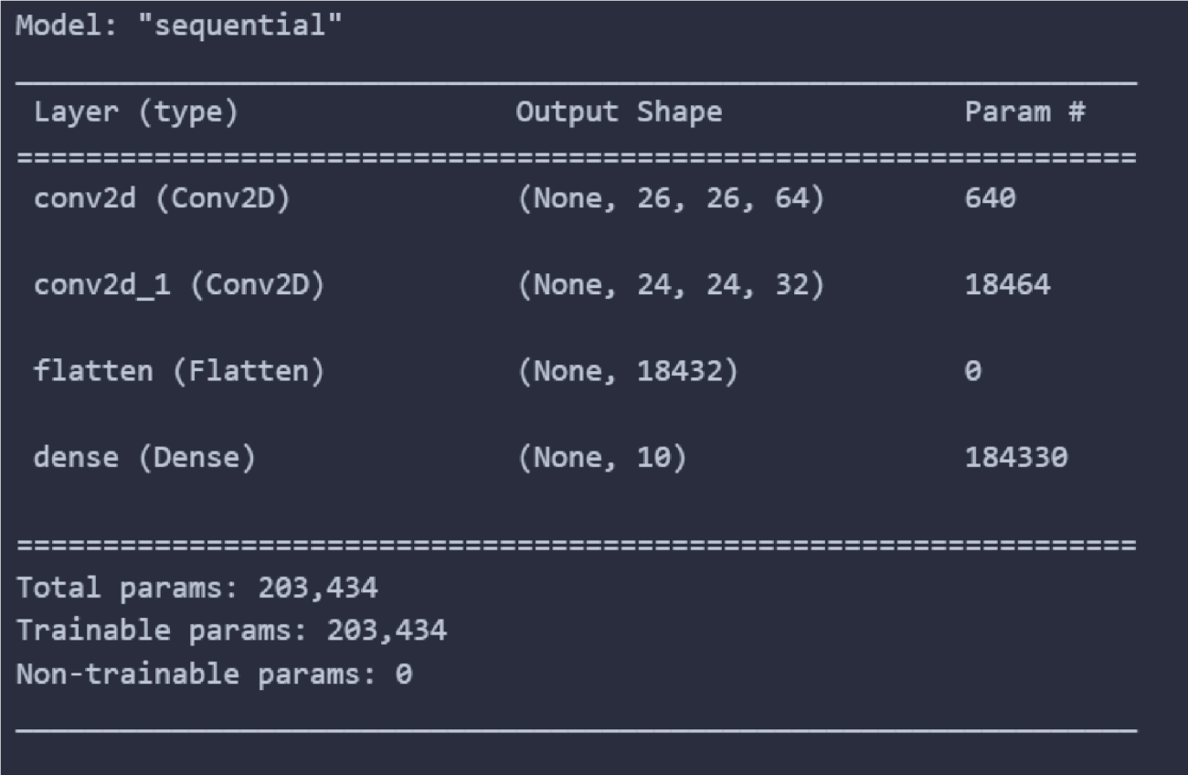**MODEL SUMMARY**

### ACCURACY

|  |  |
| --- | --- |
| **C ONTENT** | **VALUE** |
| Training Ac c urac y | 99 .14 % |
| Training Loss | 2.70 % |
| Validation Ac c urac y | 97.76 % |
| Validation Loss | 10 .36 % |

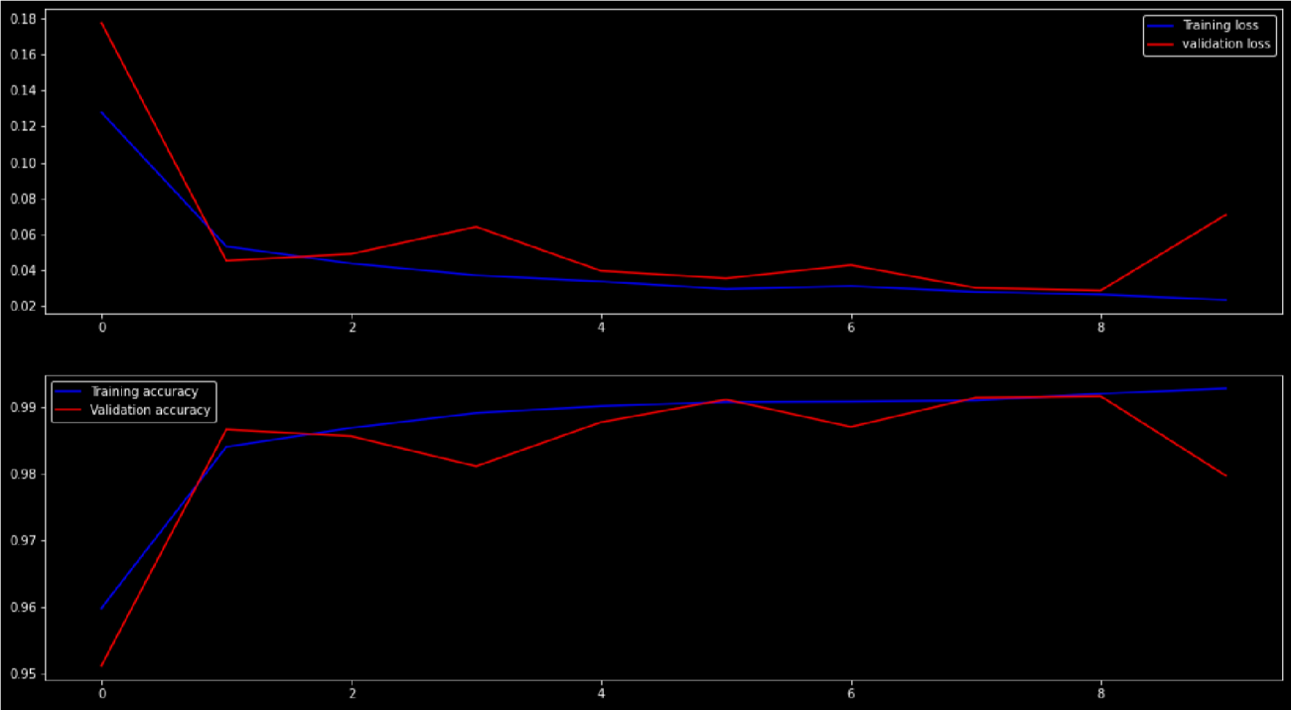

* + 1. 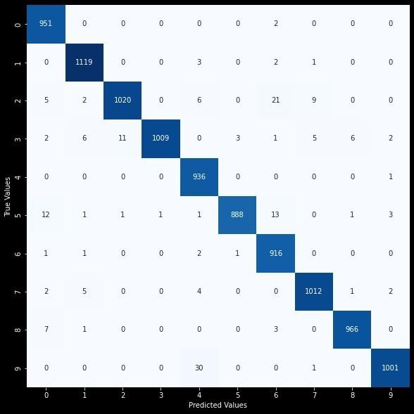**CONFUSION MATRIX**

### CLASSIFICATION REPORT

* + 1. **APPLICATION TEST REPORT**

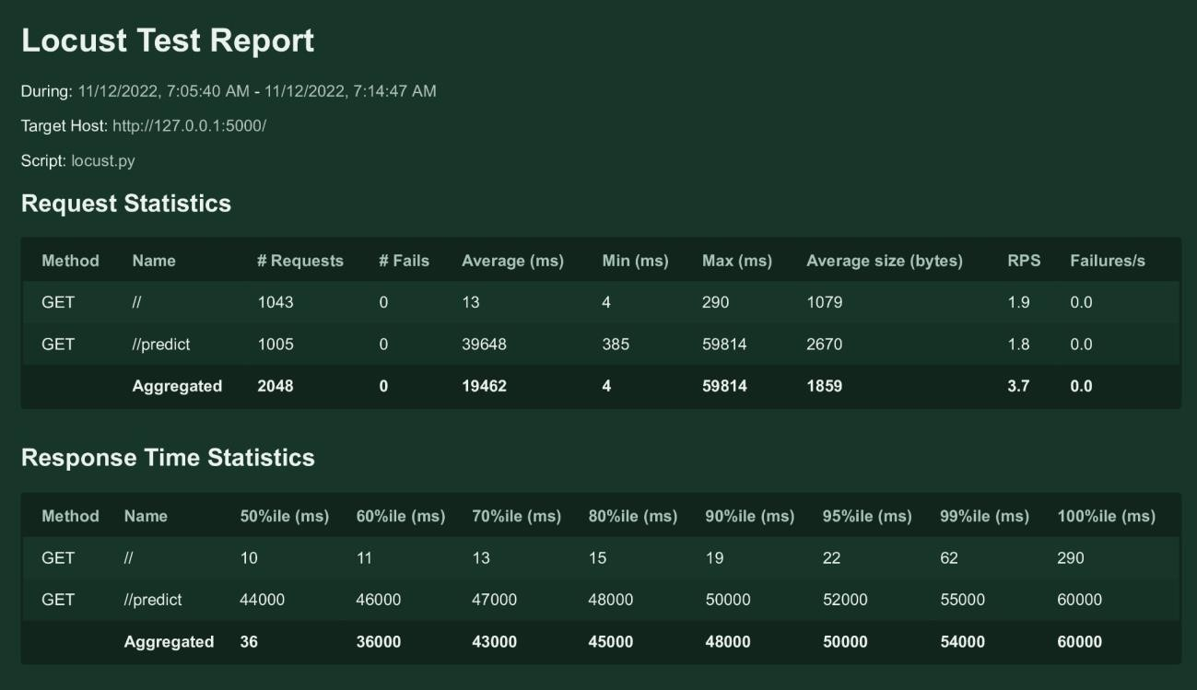

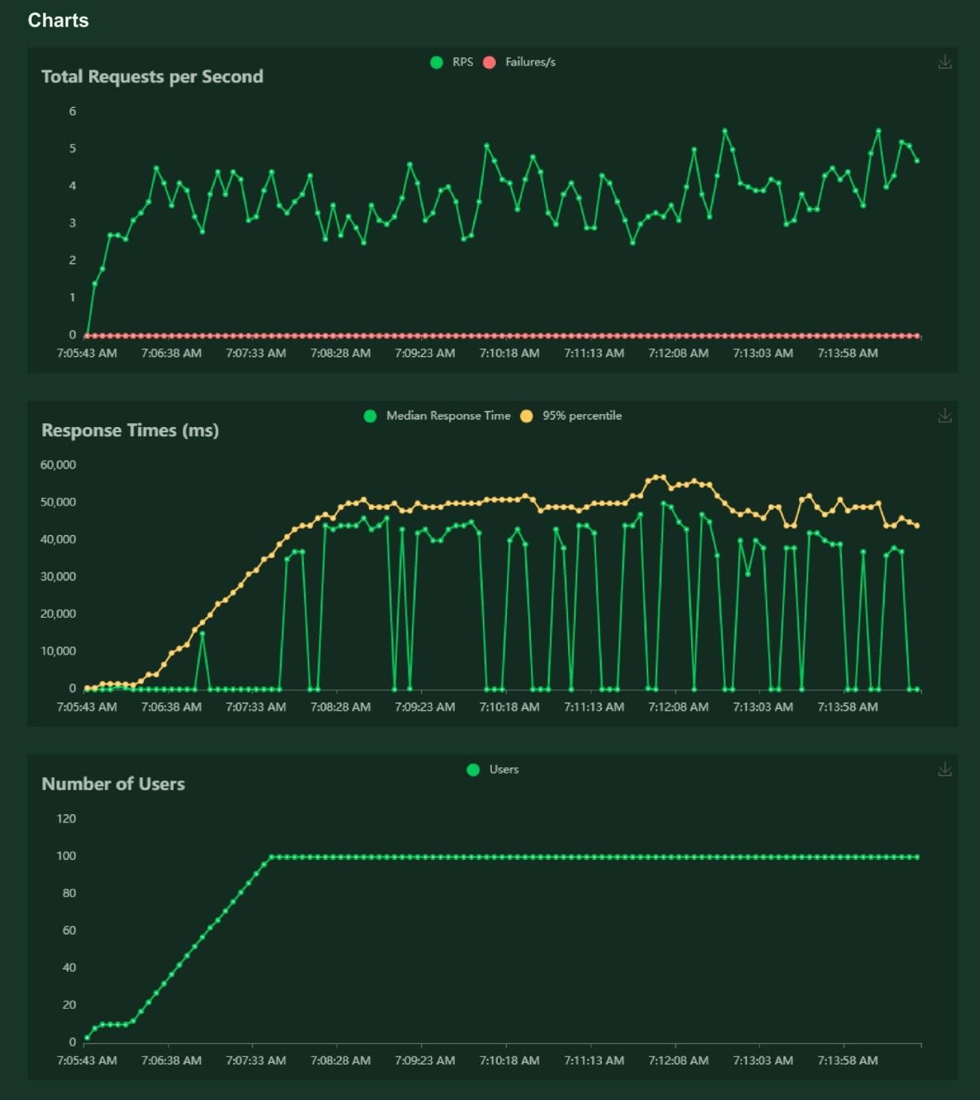

# CHAPTER 10

## ADVANTAGES & DISADVANTAGES

### ADVANTAGES

* + - * Reduces manual work
      * More accurate than average human
      * Capable of handling a lot of data
      * Can be used anywhere from any device

### DISADVANTAGES

* + - * Cannot handle complex data
      * All the data must be in digital format
      * Requires a high performance server for faster predictions
      * Prone to occasional errors

**CHAPTER 11**

## CONCLUSION

This project demonstrated a web application that uses machine learning to recognise handwritten numbers. Flask, HTML, CSS, JavaScript, and a few other technologies were used to create this project. The model predicts the handwritten digit using a CNN network. During testing, the model achieved a 99.61% recognition rate. The proposed project is scalable and can easily handle a huge number of users.

Since it is a web application, it is compatible with any device that can run a browser. This project is extremely useful in real-world scenarios such as recognizing number plates of vehicles, processing bank cheque amounts, numeric entries in forms filled up by hand (tax forms) and so on. There is so much room for improvement, which can be implemented in subsequent

versions.

# CHAPTER 12

## FUTURE SCOPE

This project is far from complete and there is a lot of room for improvement. Some of the improvements that can be made to this project are as follows:

* + - * Add support to detect from digits multiple images and save the results
      * Add support to detect multiple digits
      * Improve model to detect digits from complex images
      * Add support to different languages to help users from all over the world

This project has endless potential and can always be enhanced to become better. Implementing this concept in the real world will benefit several industries and reduce the workload on many workers, enhancing overall work efficiency.

## APPENDIX

### SOURCE CODE

Model Creaation

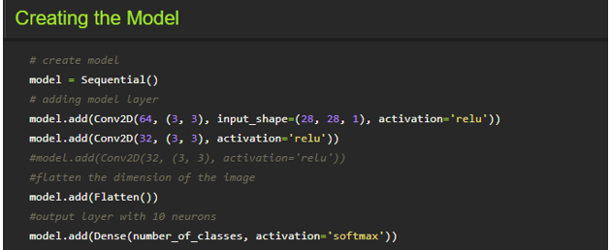

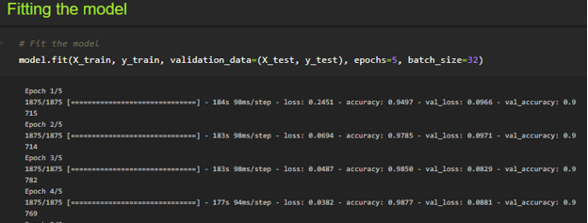

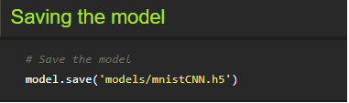





Reconizer

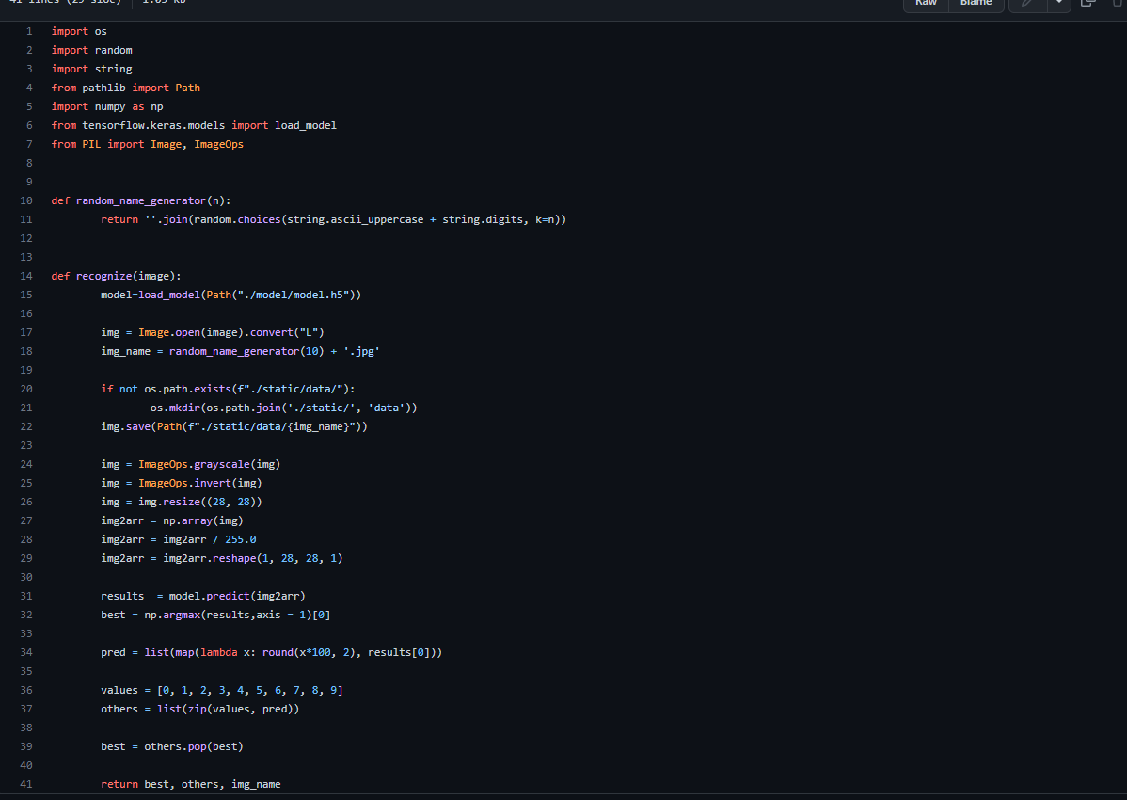

HOME PAGE (HTML)

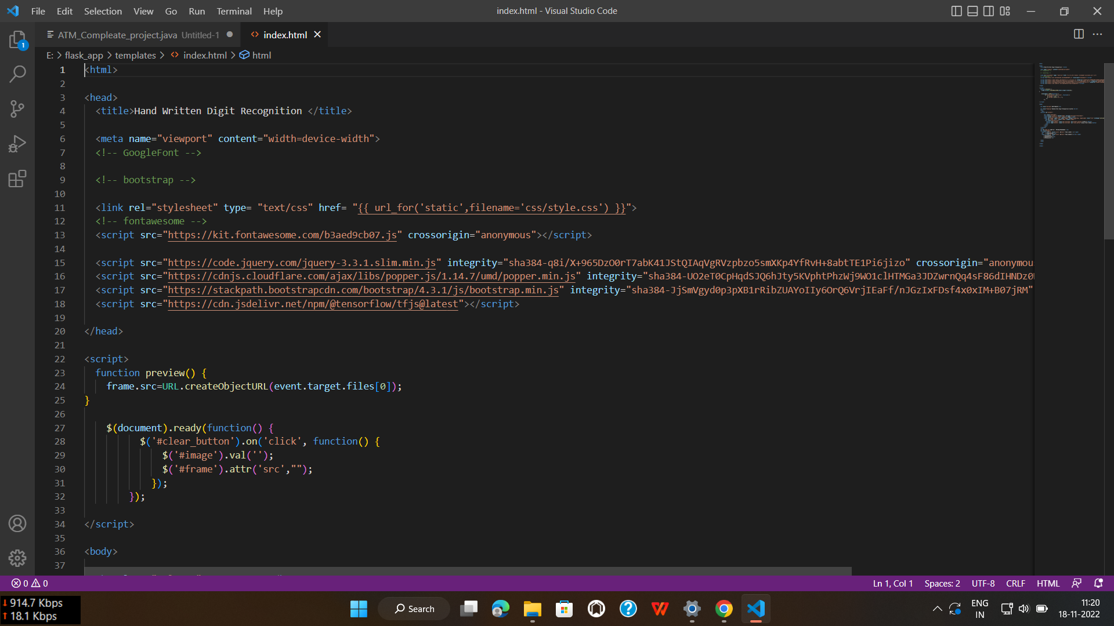

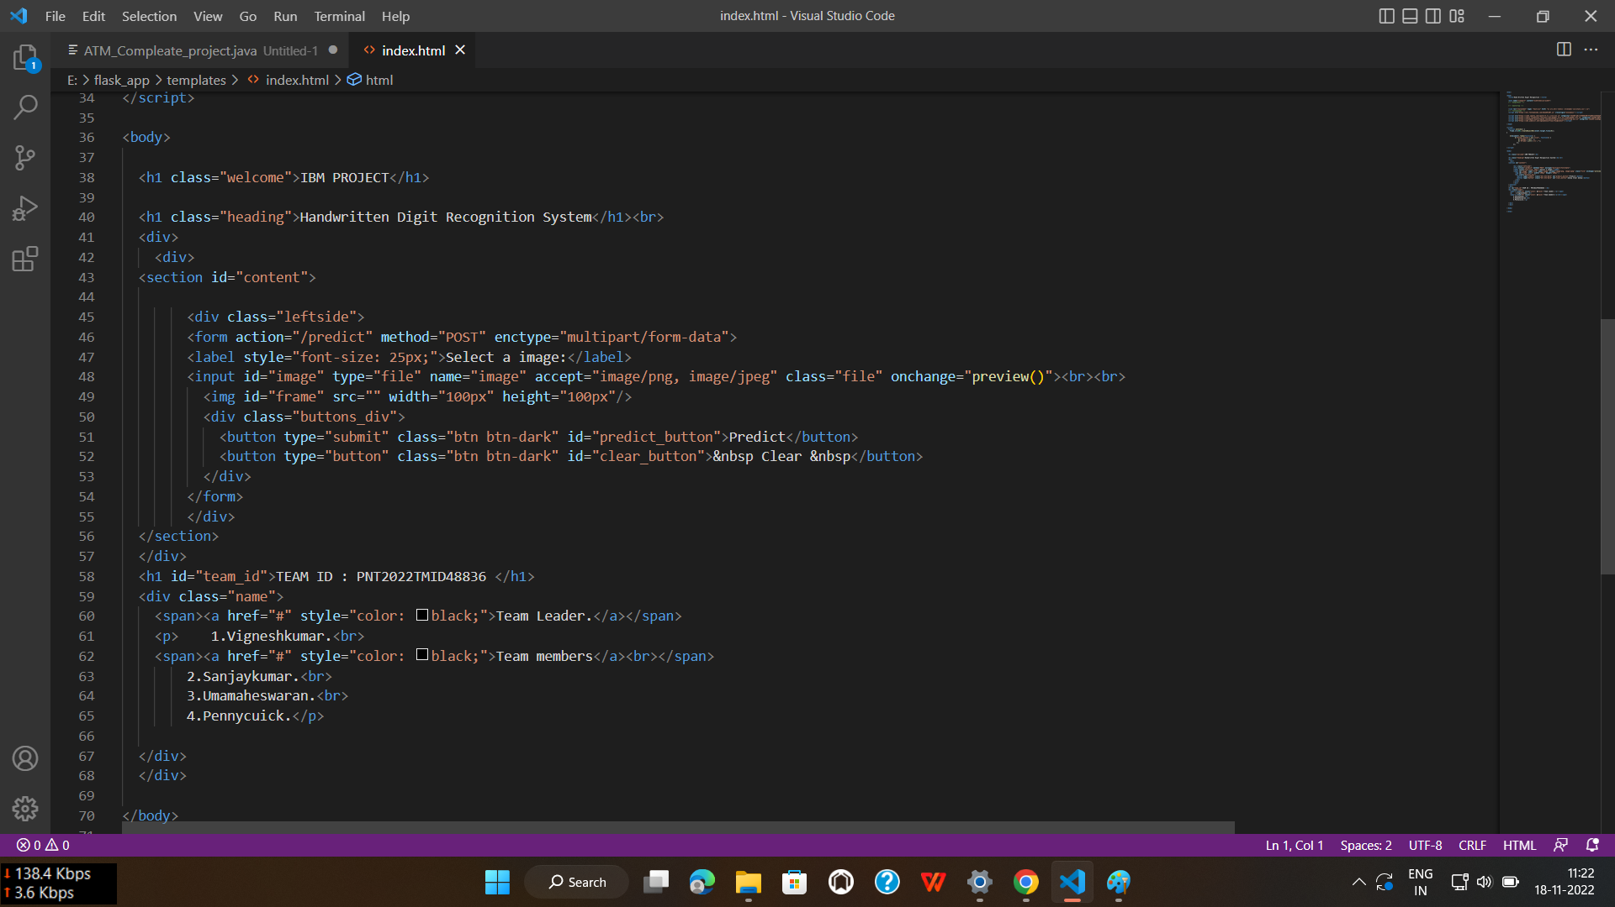

HOME PAGE (CSS)

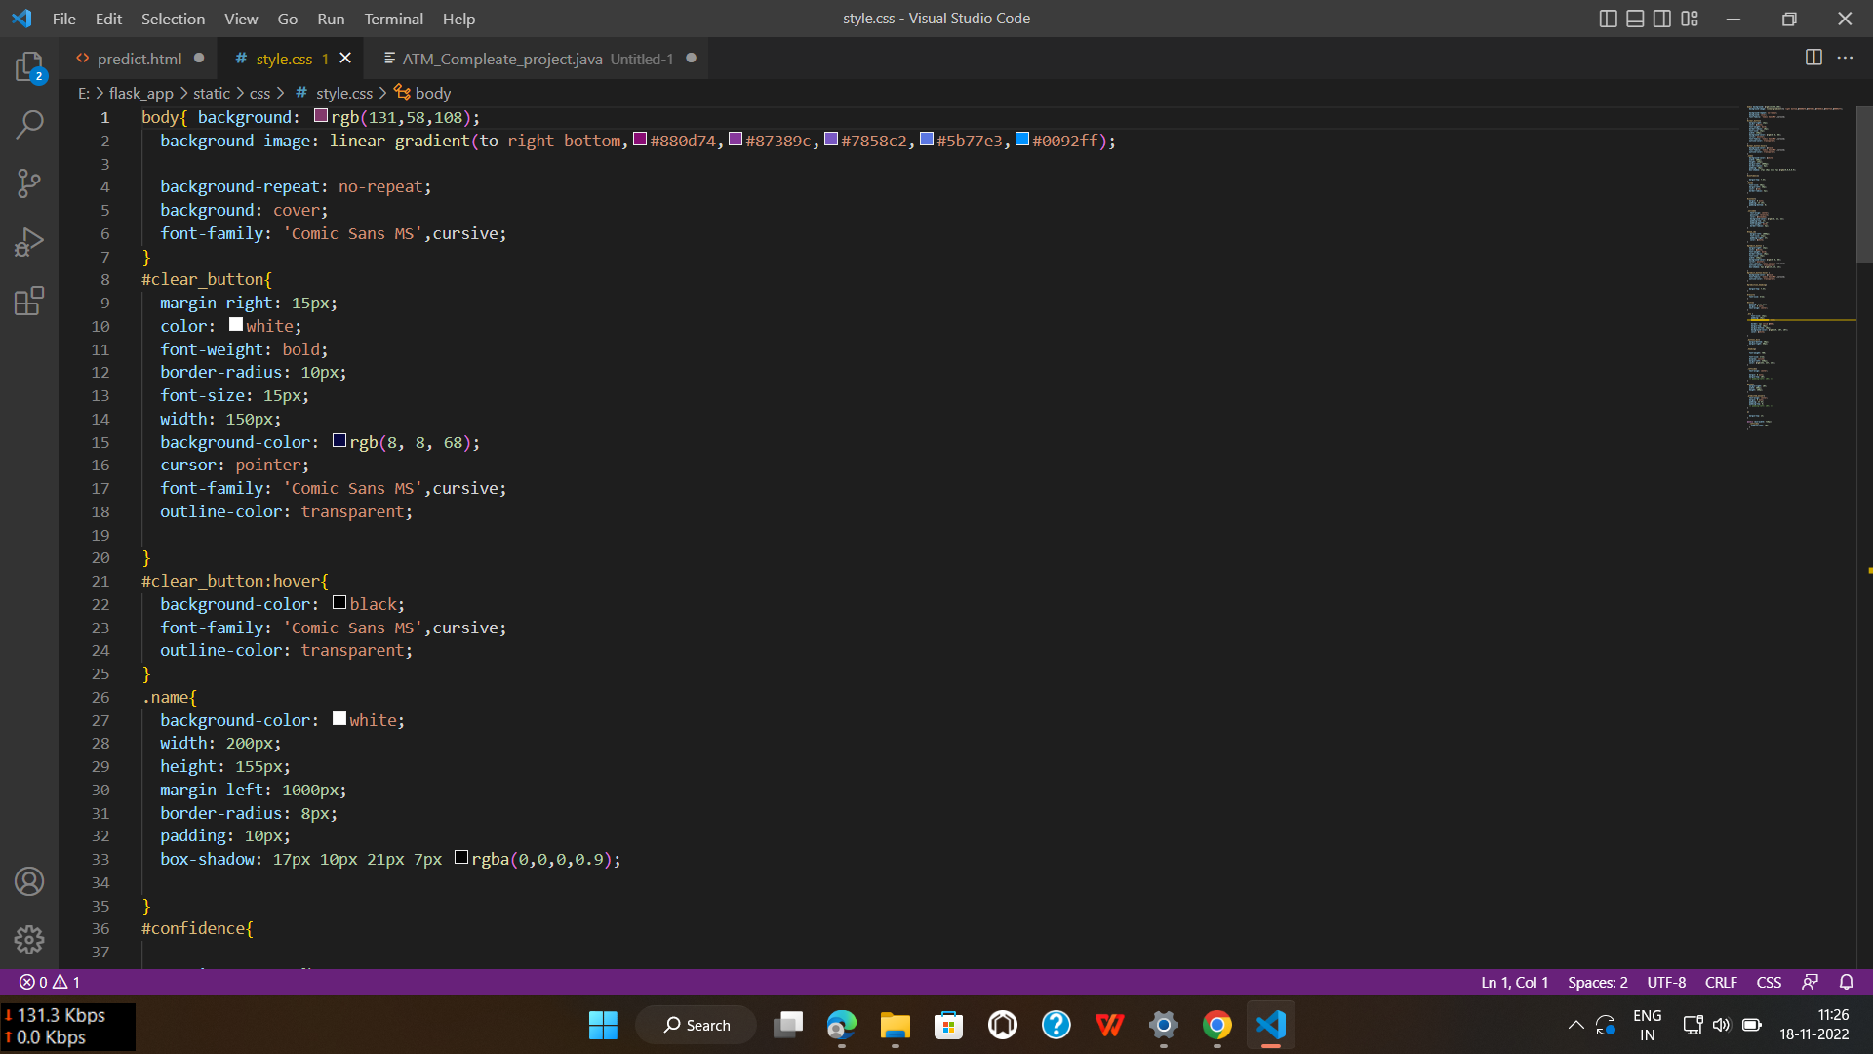

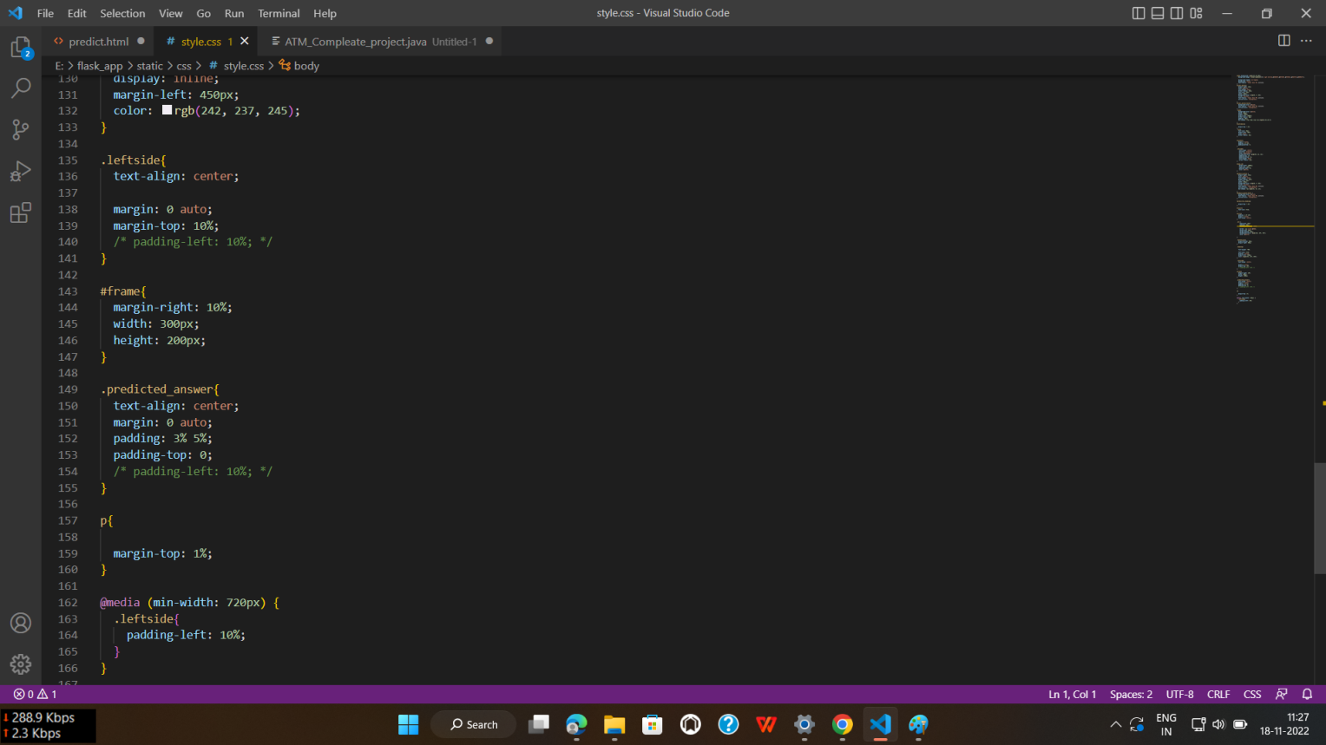

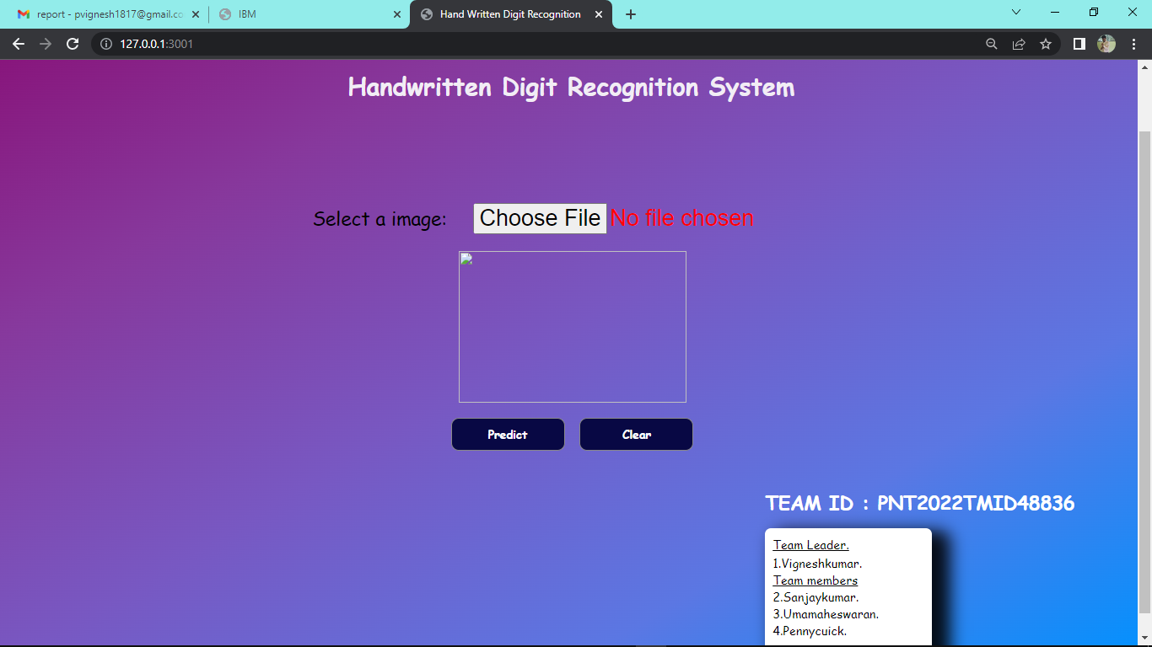

PREDICT PAGE (HTML)

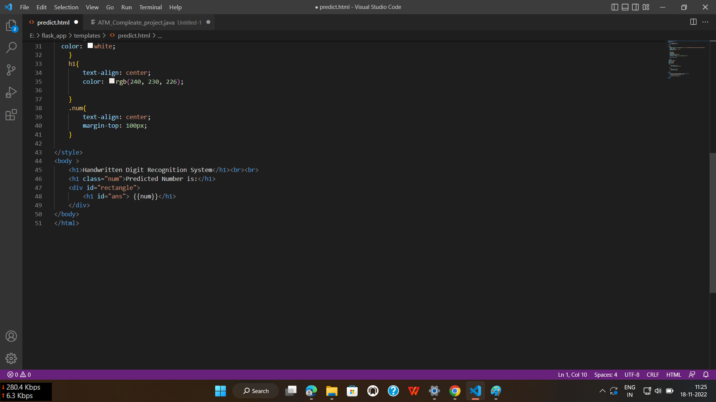

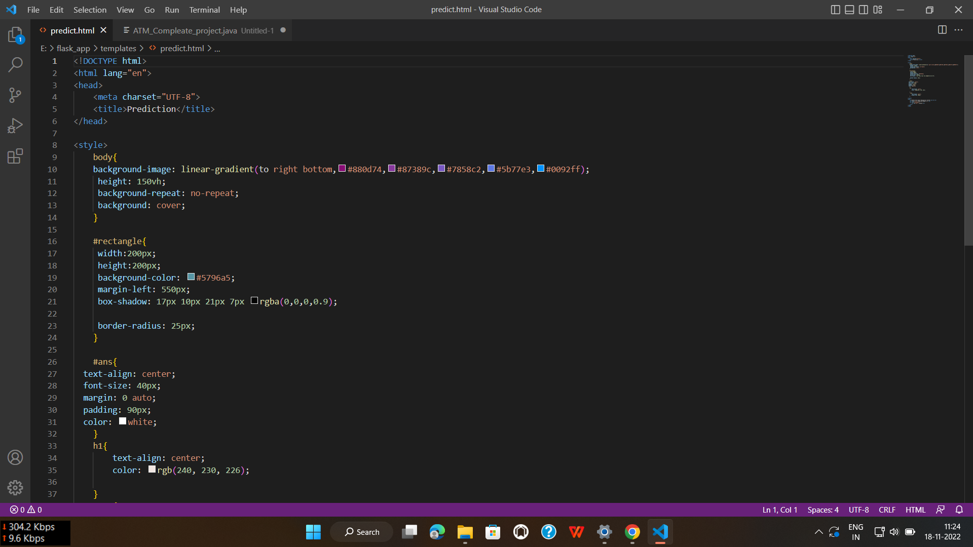

### Screenshot (19)

### GITHUB

HTTP://github.com/IBM-EPBL/IBM-Project-41289-1660640937

### PROJECT DEMO

<https://drive.google.com/file/d/1J62Go4I2SQe_DyYmqGAdEcTeTKwct8Am/view?usp=share_link>